Time Invariance for an Integrator
Prof. Brian L. Evans and Mr. Jaehong Moon
Dept. of Electrical and Computer Engineering
The University of Texas at Austin
February 17, 2022, and updated January 2, 2023

When evaluating system properties, we treat a system as a closed box and analyze the relationships between input signals and their corresponding output signals. This process assumes that after inputting a signal, we can return the system to its original state.
A continuous-time system with input signal $x(t)$ and output signal $y(t)$ is time-invariant (shift-invariant) if whenever the input signal is delayed by $t_{0}$ seconds, then the output signal will always be delayed by $t_{0}$seconds as well for all real values of $t_{0}.$
A way to visualize the time-invariance property is to show the equivalence between
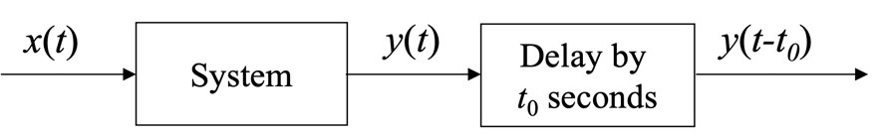
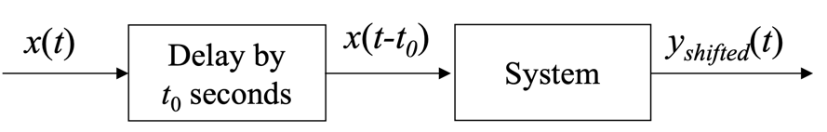
That is, does $y_{shifted}\left(t\right)=y\left(t-t_{0}\right)$ for all possible real constant values for $t_{0}$?

Integrator. An integrator captures the idea of conservation or storage [1]. “Capacitors can be modeled as integrators (capacitors are reservoirs for electric charge).” [1] The integrator integrates the input signal $x(t)$; i.e., the output of the integrator is
$$y\left(t\right)=\int_{-∞}^{t}{x\left(λ\right)}dλ$$

Two-sided infinite observation. For this case, we observe the input and output signals for all time, i.e. $-∞<t<∞$. We can determine if the system is time-invariant as follows. We delay the input signal $x\left(t-t_{0}\right)$ and analyze the resulting output signal
$$y_{shifted}\left(t\right)=\int_{-∞}^{t}{x\left(λ -t_{0}\right) dλ }$$
and see if it is equal to $y\left(t-t_{0}\right)$. We can use a change of variables $ξ=λ -t_{0}$ which means that $dξ=dλ$, $ξ_{upper}=t -t_{0}$ and $ξ_{lower}=-∞$ to obtain
$$y_{shifted}\left(t\right)=\int_{-∞}^{t-t_{0}}{x\left(ξ\right) dξ= }y\left(t-t_{0}\right)$$
Conclusion: An integrator under two-sided observation in time is time-invariant.

One-sided infinite observation. In this case, we observe the input and output signals of the integrator for $t≥0^{-}$. Time $0^{-}$ means a time of 0 seconds before occurrence of a Dirac delta occurring at the origin. We will only allow positive values of $t_{0}$ so that the delay for the input and/or output signals will be at times being observed.
Under what conditions will the integrator be time-invariant? [2]
The integrator output for $t≥0^{-}$ is
$$y\left(t\right)=\int_{-∞}^{t}{x\left(λ\right)}dλ=\int_{-∞}^{0^{-}}{x\left(λ\right)}dλ+\int_{0^{-}}^{t}{x\left(λ\right)}dλ=C_{0}+\int_{0^{-}}^{t}{x\left(λ\right)}dλ$$
The scalar constant $C_{0}$captures the result of the integration of the input signal over time not observed from $-∞<t<0$. Delaying the output signal by $t_{0}$ seconds gives
(1)
$$y\left(t-t_{0}\right)=C_{0}+\int_{0^{-}}^{t-t_{0}}{x\left(λ\right) dλ }$$
for $t≥0^{-}$. For $0^{-}<$ $t< t_{0}$ , the integral accesses values of the input signal $x(t)$ from $-t_{0}<t<0$ which we are not able to observe.
When delaying the input signal $x\left(t-t_{0}\right)$, the resulting output signal for $t≥0^{-}$ is
$$y_{shifted}\left(t\right)=C_{0}+\int_{0^{-}}^{t}{x\left(λ -t_{0}\right) dλ }$$That is, the integrator has its own time reference, and shifting the input or output signal in time does not affect the clock internal to the integrator.
To help compare $y\left(t-t_{0}\right)$ and $y_{shifted}\left(t\right)$, we perform algebraic manipulations on
$$y_{shifted}\left(t\right)=C_{0}+\int_{0^{-}}^{t}{x\left(λ -t_{0}\right) dλ }$$
We use a substitution of variables $ξ=λ-t_{0}$ which means that $dξ=dλ$, $ξ_{upper}=t-t_{0}$ and $ξ_{upper}=-t_{0}$ to obtain
(2)
$$y_{shifted}\left(t\right)=C_{0}+\int_{-t_{0}}^{t-t_{0}}{x\left(ξ\right) dξ }$$
$$y_{shifted}\left(t\right)=C_{0}+\int_{-t_{0}}^{0^{-}}{x\left(ξ\right) dξ }+\int_{0^{-}}^{t-t_{0}}{x\left(ξ\right) dξ}$$
$$y_{shifted}\left(t\right)=C_{0}+C_{1}(t_{0})+\int_{0^{-}}^{t-t_{0}}{x\left(ξ\right) dξ}$$
For (1) and (2) to be equal for $t≥t_{0}$, $C_{1}(t_{0})$ has to be zero for all values of $t_{0}$. That is, when integrating $x\left(t\right)$ with respect to $t$ from $-t_{0}$ to $0^{-}$, the answer is always 0 regardless of the value of $t_{0}$. The only way for this to happen is if $x\left(t\right)$ has amplitude of zero for $-t_{0}<t<0^{-}$. This means that as $t_{0}→∞,$ $C_{0}→0$.
Alternately, as $t_{0}→∞,$ $C_{1}(t_{0})→C_{0}$. In the limit, a necessary condition for (1) and (2) to be equal for $t≥t_{0}$ is for $C_{0}=0$ to solve $C_{0}=2{ C}_{0}$.
Conclusion: An integrator observed for $t≥0^{-}$ is time-invariant if the initial condition is 0.

References
[1] Pedro Albertos and Iven Mareels, Feedback and Control for Everyone, Springer, 2010.
[2] Stack Exchange, “Consider the integrator and check for time invariance”, April 14, 2019.

